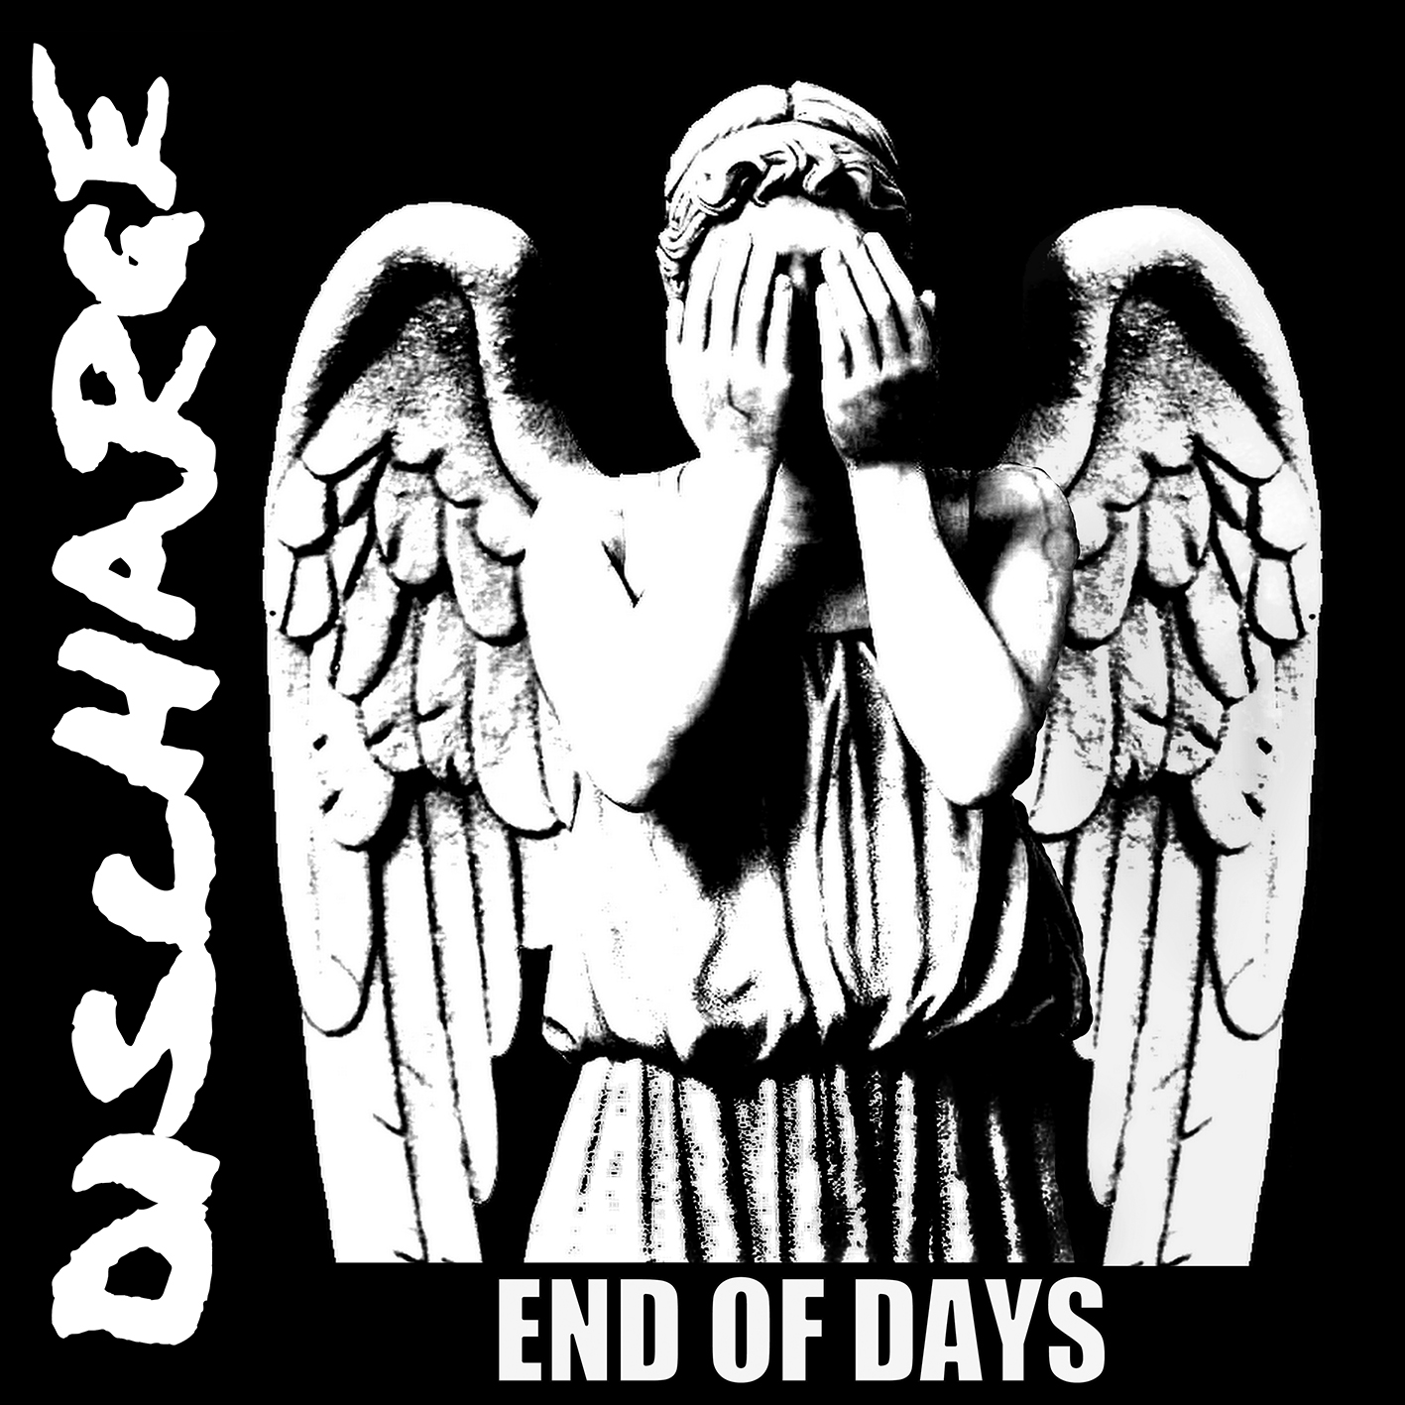

DISCHARGE
»End Of Days«

OUT: April, 29th 2016

Line up: | DISCHARGE online:
Jeff Janiak (JJ) | vocals  Tony Roberts (Bones) | lead guitar  Terry Roberts (Tezz) | rhythm guitar  Roy Wainright (Rainy) | bass  Dave Bridgewood | drums | www.facebook.com/dischargeofficial  www.nuclearblast.de/discharge

‎“Can you hear the sound of an enormous door slamming in the depths of hell…?”

Not only is this the chilling description given of a nuclear detonation during one of the sound-bite samples on the first DISCHARGE album, but it’s also a perfect description of the Stoke, UK-based punk band that turned the world of underground music on its head with their primal bursts of uncompromising speed and aggression.

Formed in the late seventies by twin brothers Bones and Tezz Roberts, and Rainy Wainwright, DISCHARGE changed the face of punk - and indeed extreme music itself - with their stunning »Realities Of War« EP, a four-song outpouring of pure intensity that boiled punk down to its basic components of rage, frustration and violent rebellion. Joined by Cal Morris, a diminutive vocalist with the roar of a lion, DISCHARGE stumbled upon a sound that was so ugly, it was beautiful; so horrifying, it was irresistible - and it ushered in a whole new wave of gnarlier, nastier UK punk, and ultimately paved the way for hardcore and thrash.

The onslaught continued with classic release after classic release, each more devastating than the previous: the five-track »Fight Back« EP, which saw the band fusing anarcho-punk anti-war sentiment to their incendiary noise, the »Decontrol« 7”, which is probably still the most brutal punk single ever released, and the incredible - in its sheer unrelenting viciousness - »Why?’« 12”.

DISCHARGE were seemingly unstoppable, and a thousand bands spawned in their wake, making them one of the few bands to have fathered their very own genre, “Discoreʺ or “D-Beatʺ as it’s now widely known around the world. Many of the songs from the band’s formative years have been covered by some of the biggest names in rock and metal music: METALLICA, ANTHRAX, SEPULTURA, MACHINE HEAD, to name but a few... all of them keen to tip their hat to this ground-breaking band, but all of them coming up short when it comes to capturing the same kind of primal ferocity.

Of course there were the inevitable line-up changes, too many to even start to list over the years, but undeterred the band released their debut LP, »Hear Nothing, See Nothing, Say Nothing«, in 1982, a towering feat of musical aggression that smashed its way into the UK charts and saw the band travelling the world, spreading their virulent sonic disease.

The »State Violence State Control« 7” followed the same year, and was a glorious parting shot from guitarist Bones, who departed to form BROKEN BONES, and without him DISCHARGE started to wander from the punk path, slowing down and becoming more metallic and rock with each release, bottoming out with 1986’s much-maligned »Grave New World«.

But the less said about that, the better. Things improved slightly with edgy early nineties offerings, »Massacre Divine« and »Shootin’ Up The World«, although they were still a million miles away from the classic DISCHARGE sound everyone was starting to think long since lost.

And then it happened. DISCHARGE turned a corner when the original line-up that had recorded the early EPs reunited for the eponymous »Discharge« LP in 2002. A welcome return to form that saw the band wholeheartedly embracing their punk roots once again, fans were keen to see the band hit the road in support of it, but Cal wouldn’t commit to live shows and was replaced by Rat Martin from THE VARUKERS.
Rat fronted the band for the next ten years, a decade that saw DISCHARGE back on top of their game, touring internationally and releasing the well-received »Disensitise« LP, not to mention the »Beginning Of The End« and »War Is Hell« EPs, all of which saw them finally reclaiming the simplistic raw punk style they themselves created over thirty years ago.

And the passing of time has done little to tame their ferocity. With a brand new vocalist Jeff “JJʺ Janiak (from BROKEN BONES) revitalising their creativity, and Tezz Roberts back in the fold on second guitar to beef out their sound like never before, the current line-up, completed by Bones, Rainy, and drummer Dave Caution, have signed to Nuclear Blast, to unleash their new single 'New World Order', and the aptly-titled album »End Of Days«.

The nightmare continues.

©Ian Glasper

